Assignment 1 - COMP3132 - Winter 2025

## Introduction

Fashion MNIST is an alternative to MNIST. It is another default dataset that we can access through Keras.

Fashion MNIST is a dataset of 60,000 28x28 grayscale images of 10 fashion categories, along with a test set of 10,000 images. This dataset can be used as a drop-in replacement for MNIST.

The class labels are:

1. T-shirt/top
2. Trouser
3. Pullover
4. Dress
5. Coat
6. Sandal
7. Shirt
8. Sneaker
9. Bag
10. Ankle boot

The dataset is a bit more challenging compared to MNIST, and the achieved accuracy is normally less than what we can get from the classical MNIST.

This is where we will start importing and loading our dataset:

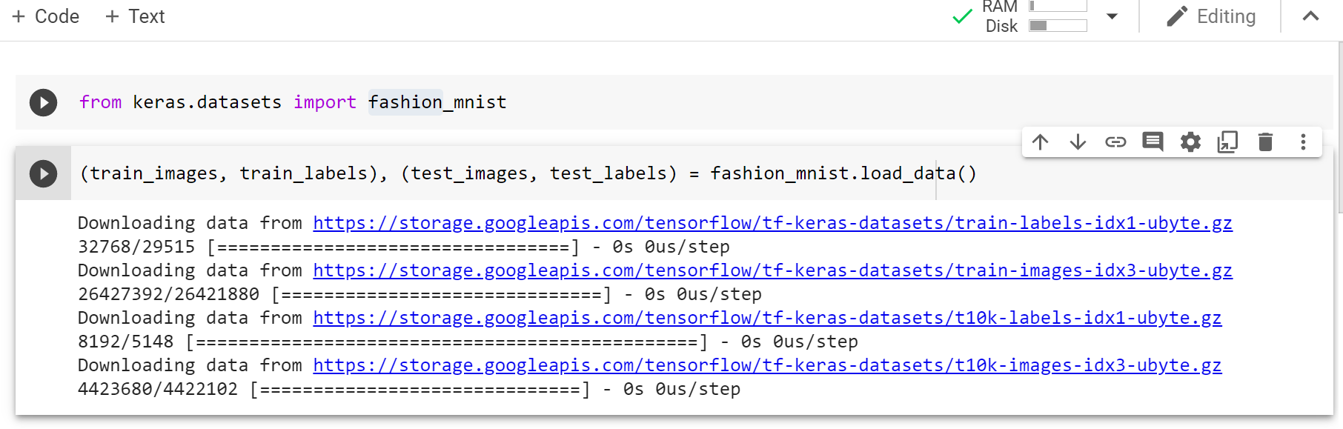

## Instructions

Next, answer the following questions in your code, and explain your code in the video:

1. What are the dimensions of train_images, train_labels, test_images, and test_labels?
2. What are the lengths of train_labels and test_labels?
3. Please show some of the train and test labels.
4. Please show the digital content of image index 5 in the training dataset.
5. Please plot the image of the index 5 in the training dataset.
6. What is the label for the index 5 in the train_label and looking up in the above list, what does it mean?
7. Please show the digital content of image index 500 in the testing dataset.
8. Please plot the image of the index 500 in the testing dataset.
9. What is the label for the index 500 in the test_label and looking up in the above list, what does it mean?
10. Please import models and layers from the keras library.
11. Define a sequential model and call it myNetwork.
12. Reshape the images from 28x28 to one column with 784 neurons (flattening)
13. Also, please normalize the image by dividing the image by 255
14. Add one hidden layer that has 512 neurons, using the ‘relu’ activation function.
15. Add another hidden layer that has 128 neurons, using the ‘relu’ activation function.
16. Add the last layer as a 10-neuron dense layer that uses the ‘softmax’ as the activation function. Why do we use softmax for the last layer? How does it work under the hood? Make sure to explain this in your video.
17. Use the following two settings for the compiler and run them separately and see what the differences are.
    1. Option A
       1. **Optimizer**: adam
       2. **loss**: 'sparse_categorical_crossentropy'
       3. **metrics**: [‘accuracy’]
    2. Option B
       1. **Optimizer**: rmsprop
       2. **loss**: 'categorical_crossentropy'
       3. **metrics**: [‘accuracy’]
18. Now after the compilation, please try to find the pattern using the fit command. Set the number of epochs to 10.
19. How do you compare the fashion_MNIST with what we learned in the class using the MNIST? Explain in your video.
20. What can we infer from the differences in the accuracy? What could be the reasons for that? Explain in your video.
21. Use the evaluate() function from the Keras library to calculate the achieved accuracy and loss over the test images and labels. Do we have overfitting? Explain in your video.

**Submission Instructions**

**Part A - assign1_firstname.ipynb Notebook (5%):**

* **assign1_firstname.ipynb** file that contains all of the code.
* Please add the Question number as a comment on the related Google Collab cell of code *or* on separate markdown cells. (1/5%)

E.g.

# Question 1

from keras.datasets import fashion_mnist

* Every question is worth /0.25 and it provides 5/10 marks for the assignment.

**Part B - Video (5%):**

* **Add the video URL in your comment box of the D2L submission folder.**
* Please record and upload a video to YouTube (or another platform as long as it's viewable for your professors online).
* Describe all you have done in approximately 5 minutes (Stay within 3-6 min).
* Make sure the video is public or unlisted - the video cannot be private. Check this using an incognito tab on your browser before submission.

**IMPORTANT:** **Without video submission the total mark is Zero.**